1. A chicken lays n eggs. Each egg independently does or doesn’t hatch, with probability p of hatching. For each egg that hatches, the chick does or doesn’t survive (independently of the other eggs), with probability s of survival. Let N ⇠ Bin(n, p) be the number of eggs which hatch, X be the number of chicks which survive, and Y be the number of chicks which hatch but don’t survive (so X + Y = N). Find the marginal PMF of X, and the joint PMF of X and Y . Are they independent?

**Ans : Marginally we have X ∼ Bin(n, ps), as shown on a previous homework problem using a story proof (the eggs can be thought of as independent Bernoulli trials with probability ps of success for each). Here X and Y are not independent, unlike in the chicken-egg problem from class (where N was Poisson). This follows immediately from thinking about an extreme case: if X = n, then clearly Y = 0. So they are not independent: P(Y = 0) < 1, while P(Y = 0|X = n) = 1.**

**To find the joint distribution, condition on N and note that only the N = i+j term is nonzero: for any nonnegative integers i, j with i + j ≤ n,**

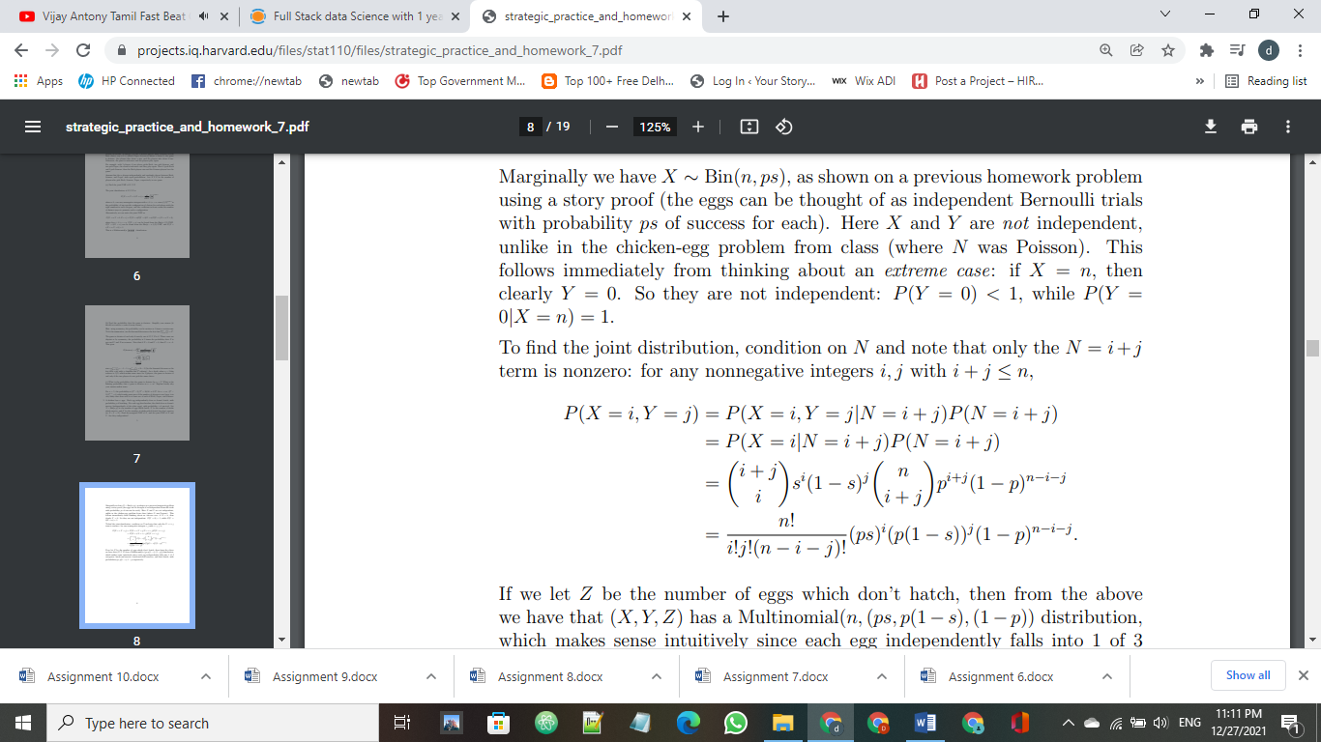

**If we let Z be the number of eggs which don’t hatch, then from the above we have that (X, Y, Z) has a Multinomial(n,(ps, p(1 – s),(1 – p)) distribution, which makes sense intuitively since each egg independently falls into 1 of 3 categories: hatch-and-survive, hatch-and-don’t-survive, and don’t-hatch, with probabilities ps, p(1 – s), 1 – p respectively.**